DJANGO Assignment

Task 1

Task 2

Task 3

Task 4

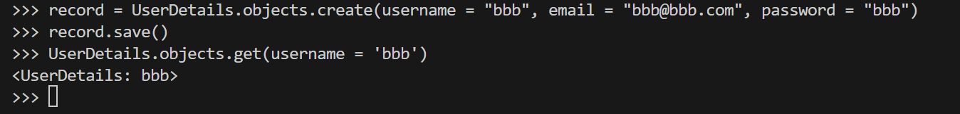

Task 5

